DAY 01
1. Create a table listing 3 types of printers, 2 types of scanners, and 2 types of webcams, and for each, write one real-life use case (for example: 'Inkjet printer – printing college assignments').
Laser Printer = Printing large numbers of office documents quickly.
Dot Matrix Printer = Printing bills and multi-copy receipts in shops.
Inkjet Printer = Printing college assignments, photos, and colorful documents.
Flatbed Scanner = Scanning certificates, photos, and important documents.
Sheet-fed Scanner = Scanning multiple pages of office documents quickly.
Built-in Webcam = Attending online classes or meetings on a laptop.
External USB Webcam = Making video calls and attending online interviews on a desktop PC.
2. Draw a labeled diagram showing how a typical home printer connects to a laptop or PC, including the connection interface used (USB, Wi-Fi, or Bluetooth).
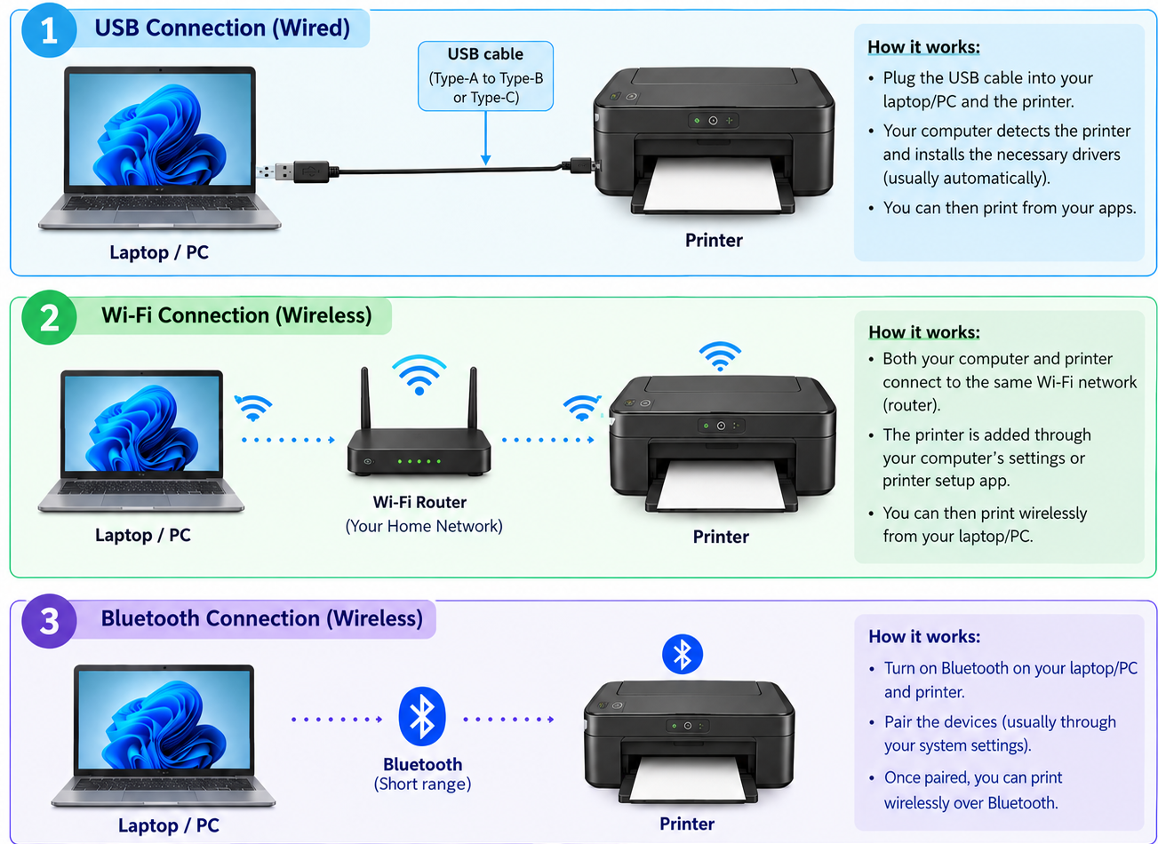

3. List three different connection interfaces (such as USB, Wi-Fi, Bluetooth) used by peripherals like printers, scanners, and webcams, and for each, name one advantage and one disadvantage. <br><br><em><strong>Hint:</strong> Think about speed, convenience, and compatibility.</em>.
Connection Interface | Advantage | Disadvantage
USB (Wired) | Provides a reliable, fast connection and is easy to set up. | Requires a cable and a suitable USB port.
Wi-Fi (Wireless) | Allows multiple devices to connect to a printer without cables. | Requires a Wi-Fi network and may experience connection problems.
Bluetooth (Wireless) | Convenient for short-range wireless connections without cables or a Wi-Fi network. | Has a shorter range and is generally slower than USB.

4.Pick any one device you use at home or college (printer, scanner, or webcam). Write step-by-step instructions for how you would connect it to your computer, including what cable or wireless method you would use and any setup steps required.
Connecting a Wireless Printer to a Computer at home.
Connection method: Wi-Fi (wireless connection)
Steps:
1. Turn on the printer: Connect the printer to a power supply and press the power button.
2. Connect to Wi-Fi: Open the printer’s control panel and connect it to the same Wi-Fi network used by the computer.
3. Open computer settings: On the Windows computer, click Start → Settings → Bluetooth & devices → Printers & scanners.
4. Add the printer: Click Add device and wait for the computer to detect the wireless printer.
5. Install the driver: If Windows asks for a driver, follow the on-screen instructions or install it from the printer manufacturer’s official website.
6. Select the printer: Once the printer is added, select it from the list of available printers.
7. Print a test page: Open a document, press Ctrl + P, select the printer, and click Print to check whether it works correctly.

